How to install wordpress on ubuntu series:-
1. Please follow the given link to install wordpress,
https://www.tecmint.com/install-wordpress-on-ubuntu-16-04-with-lamp/

During Installation, you might get following errors:-

1. When uploading/importing data/.xm file is morethan 2MB, it will through error like file size is exceeded. For that need to change the below mentioned file in upload_max_filesize size.
/etc/php/7.0/apache2/php.ini
/etc/php/7.0/cgi/php.ini
/etc/php/7.0/cli/php.ini

Note:-
;;;;;;;;;;;;;;;;
; File Uploads ;
;;;;;;;;;;;;;;;;

; Whether to allow HTTP file uploads.
; http://php.net/file-uploads
file_uploads = On

; Temporary directory for HTTP uploaded files (will use system default if not
; specified).
; http://php.net/upload-tmp-dir
;upload_tmp_dir =

; Maximum allowed size for uploaded files.
; http://php.net/upload-max-filesize
upload_max_filesize = 200M

; Maximum number of files that can be uploaded via a single request
max_file_uploads = 500
2. Some times getting the following errror, when rendering the admin page (https://139.59.22.116/wp-admin/)
Attackers might be trying to steal your information from 139.59.22.116 (for example, passwords, messages or credit cards).
NET::ERR_CERT_COMMON_NAME_INVALID
2.1 For that need to change the Login in wp-admin, Go to Setting ==> and chnage the below mentioned fields,
WordPress Address (URL) -- http://fixnix.co
Site Address (URL) -- http://fixnix.co
2.2 Login in to wordpress database, and change the below mentioned fields values,
mysql> select * from wp_options limit 2;
+-----------+-------------+------------------+----------+
| option_id | option_name | option_value | autoload |
+-----------+-------------+------------------+----------+
| 1 | siteurl | http://fixnix.co | yes |
| 2 | home | http://fixnix.co | yes |
+-----------+-------------+------------------+----------+
mysql> update wp_options set option_value="http://blogs.fixnix.co" where(option_id=1);
mysql> update wp_options set option_value="http://blogs.fixnix.co" where(option_id=2);
3. How to get backup of all file in wordpress,
Copy all folders/files inside html folder, to your local system,
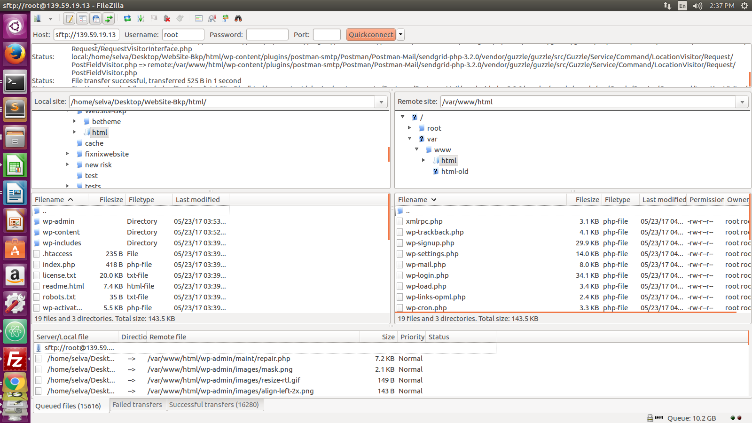

and need to change the database/username/password in /var/www/html/wp-config.php

/** MySQL database username */
define('DB_USER', 'wordpress');

/** MySQL database password */
define('DB_PASSWORD', 'ff8ba86e021808645bf6f9460461724d7e9b29c68f1d7388');

/** MySQL hostname */
define('DB_HOST', 'localhost');

/** Database Charset to use in creating database tables. */
define('DB_CHARSET', 'utf8');

/** The Database Collate type. Don't change this if in doubt. */
define('DB_COLLATE', '');

4. How to export/import the blogs data,
Login as a wp-admin, Go to Tools==>Import/Export the data’s in .xml format
5. How to apply theme’s for wordpress site,
Login as wp-admin, Go to Appearance==>Themes and then choose your theme and activate it.
When applying main theme, you can choose theme sub category also.. ie, beetheme(Main theme)==>IT Service(Sub theme)

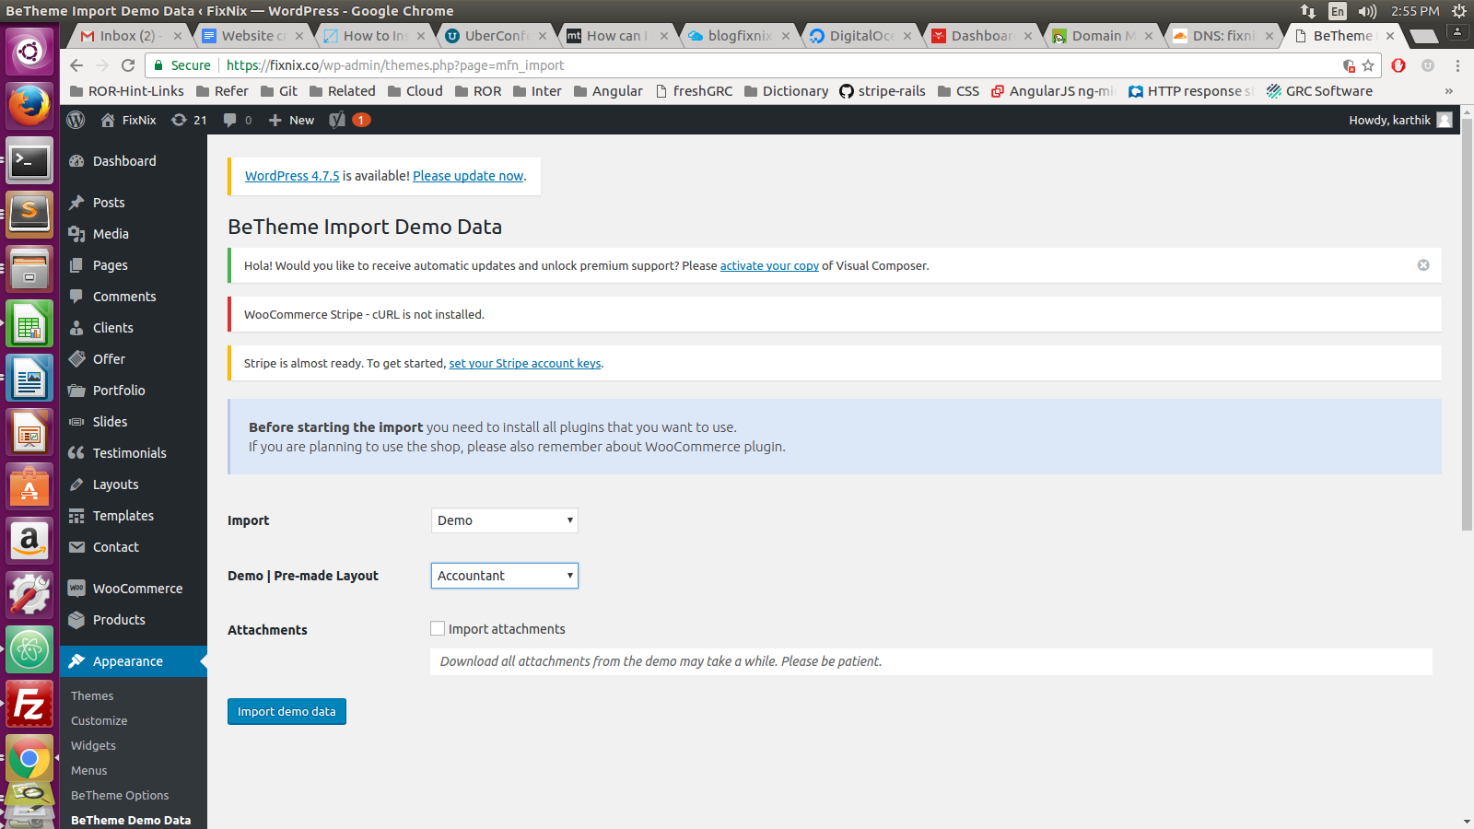

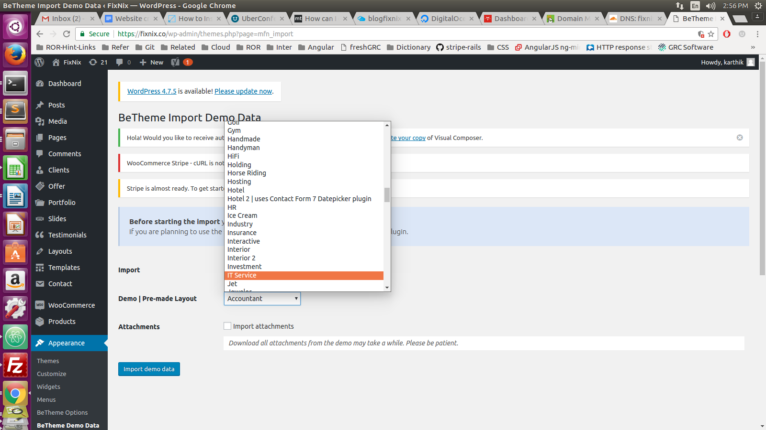

6. WordPress: Requested URL Was Not Found on this Server

Need to change /etc/apache2/apache2.conf AllowOverride None to AllowOverride All
<Directory />
Options FollowSymLinks
#AllowOverride None
AllowOverride All
</Directory>

Let's Encrypt install digital ocean/Azure:-
Let's Encrypt is a free, open and automated certificate authority (CA) provided as a service by the Internet Security Research Group (ISRG).
Let's Encrypt is designed to simplify the acquisition of SSL/TLS digital certificates proving a site’s authenticity, while also providing encryption. Its automated processes will also help reduce page errors due to out of date certificates.

To execute the interactive installation and obtain a certificate that covers only a single domain, run the certbot command with:
sudo certbot --apache -d example.com
During ssl certificate adding, you might have gettin following error,

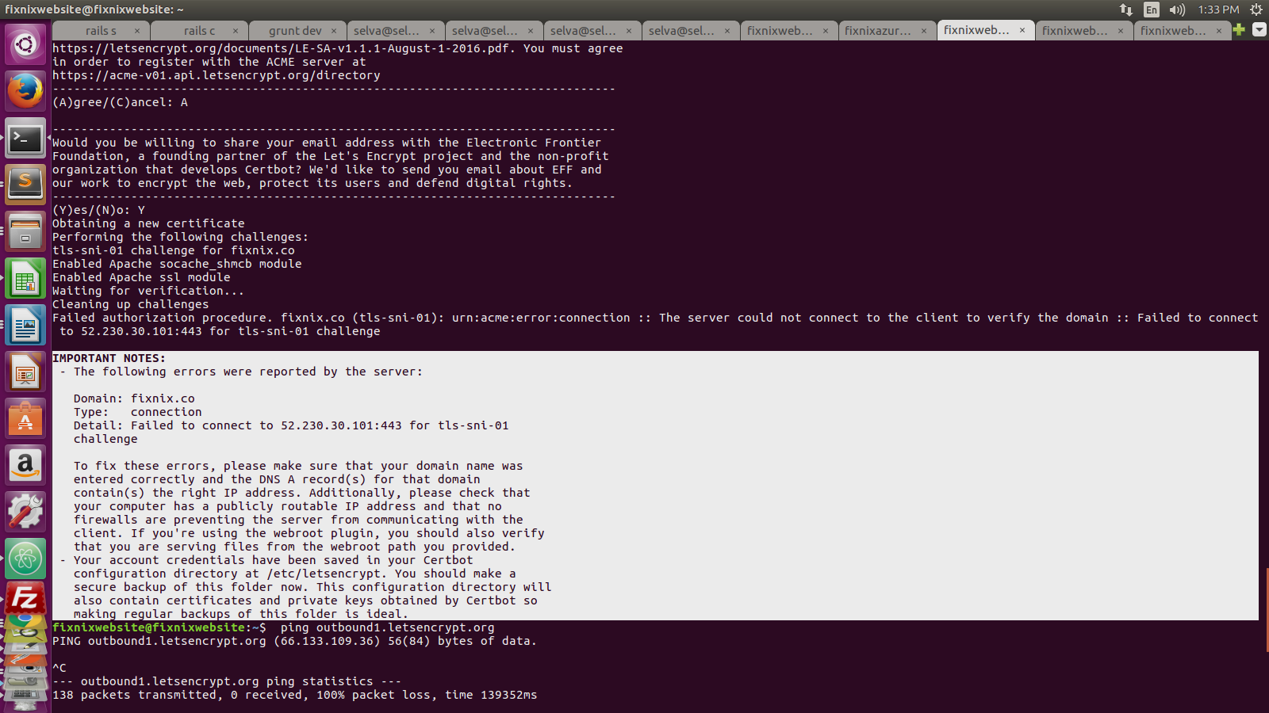
Solution:-
Need to add TCP port 443 in azure portal ==> Endpoints
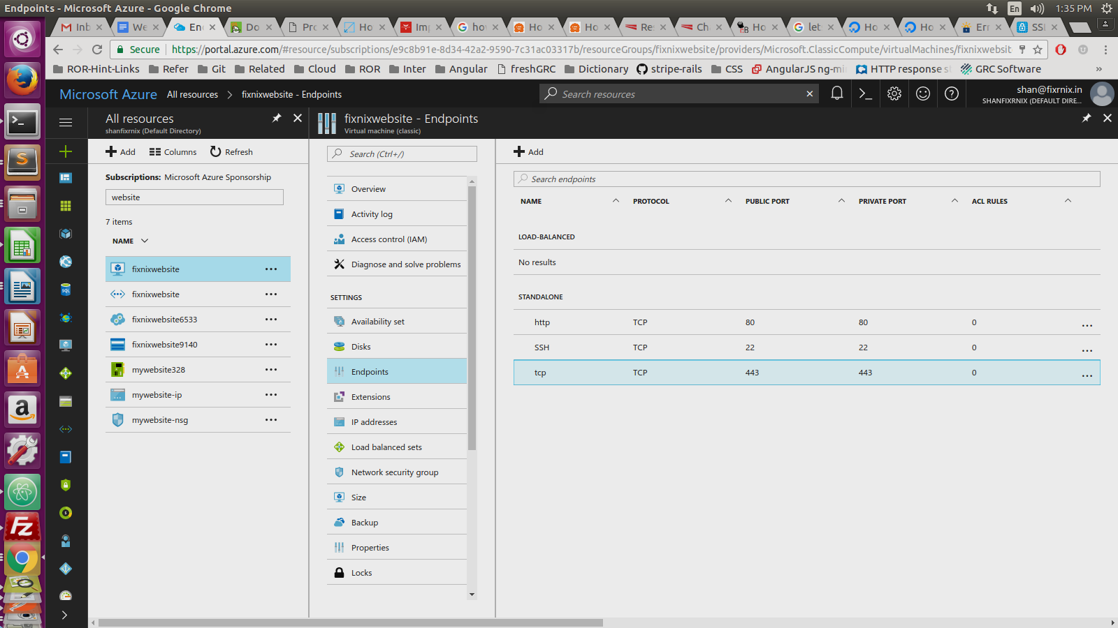

How to configure apache server to redirect some other site,
By default Apache will have /etc/apache2index.html file, it will always have apache home page screen,
In our scenario, suppose /var/www/html folder has two files index.html and index.php, by default apache will render to index.html only..
If you want apache server want redirect index.php, you need modify idex.html file name or else delete the index.html.

